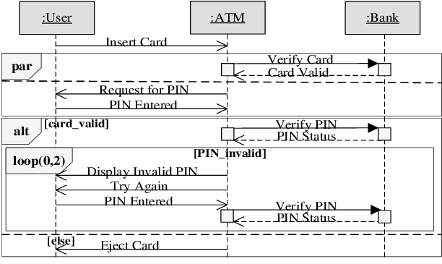

HIGH LEVEL REQUIREMENT

Scenario name  S1, retrieve money, requested amount given | General description
Step | Description | Requirement ID
1 | Read card r | R12
1A | Verify card (stolen, ..) | R14
2 | Ask PIN | R16
3 | Verify PIN | R13
4 | Ask amount | R17
5 | Read amount a
6 | Compute account c attached to card r | R19
7 | Verify if amount a is available on account c | R18
8 | Dispense cash a | R15
9 | Deduce a from account c | R20
10 | Print receipt | R4
11 | Eject card | R21

Scenario name  S5, money, card invalid | General description
Step | Description | Requirement ID
1 | Read card r | R12
2 | Verify card valid | R14
3 | Eject card | R21

S2 check balance
S3 bank transfer
S4, retrieve money, amount requested not available

